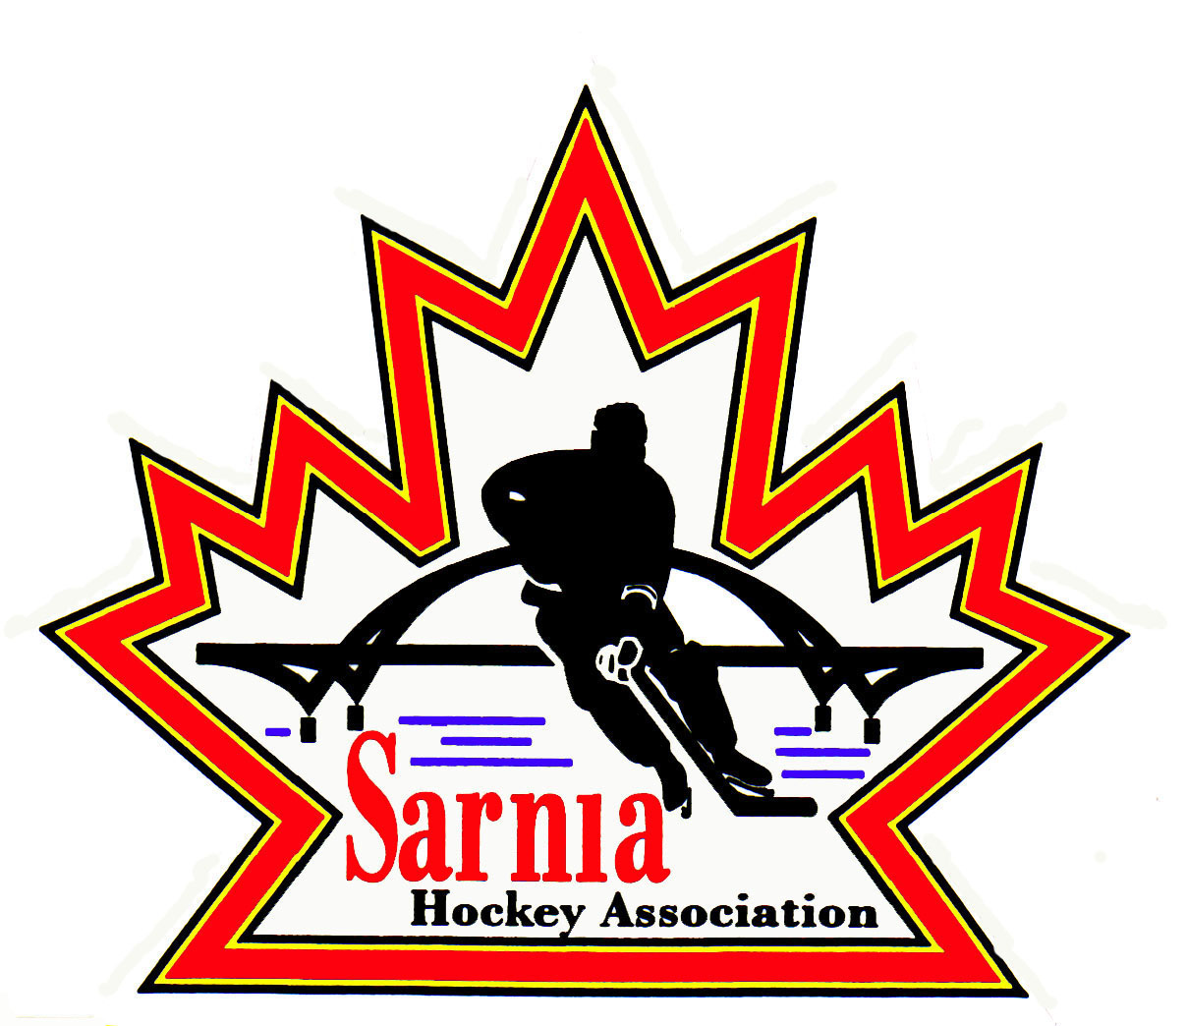

Sarnia Hockey Association

Minutes | Date: MAY 7, 2024 | time 7:00 pm

Meeting called by | Paul Walsh, President
Type of meeting | Regular
Secretary | Kelly Lane, Recording Secretary

Welcome | Paul Walsh, President and meeting Chair welcomed everyone and called the meeting to order at 8:15 pm after the Annual General Meeting.

ATTENDANCE | Andrew Beasley, Jacquie Beasley, Jerry Bernardo, Alister Brown, Emily Brown, Darren Chevalier, Paul Douglass, Ian Dunn, Chuck Ewart, Kelly Lane, Linda Lauzon, Don McGugan, John Mellor, David Penner, Wayne Scarrow, Lesley Taylor-Smith, Kevin Taylor, Barb Walsh, Paul Walsh  Regrets: Tom Babcock, Jeff Fogal, Pat Forbes, Terry Gray, Kyle Mellor, Tim Turner  Guests: Michelle Page

ACCEPTANCE OF MINUTES | MOTION #240507-001  “That the Minutes from April 27, 2024, be accepted as presented.” (Bernardo/L. Smith-Taylor)  Carried

TREASURER’S REPORT | - Bank interest is well above what was expected due to GIC investments. We are almost $10,000 above budget.  - Miscellaneous revenue and expenses are both off kilter due to Benevity grants in and out. We will be expanding our revenue statement so this is clearly documented as we are flowing through approximately $35,000 due to employee volunteer efforts.  - We have $211,612.00 in outstanding cheques . Part of this is due to a large bill to City of Sarnia for ice. This was cashed on May 2. (after the closing of our fiscal year end.)  - Rep Teams have done what was requested at RBC regarding their team bank accounts. Just waiting on RBC to provide a status report. Plan is for the accounts to turn to Savings accounts until teams are ready to open them up again for the 2024/25 season.  - Will be continuing with RBC next year.  MOTION #240507-002  “That the Treasurer’s Report be accepted as presented.” (E. Brown/Penner)  Carried

BILLS TO BE PAID | MOTION #240507-003  “That the bills be paid as presented.” (Brown/McGugan)  Carried  - Bingo account was cleared out and drawn down to zero. Money was put toward City of Sarnia ice bill.  - Working on application for Sting Assist program. The Application deadline is the end of May.
  Recipient | Expense | Amount
  WMA Promotions  Alliance  Derek DiMuzio  AW Locksmith  Alister Brown | A/AA officiating  Participant insurance  Alliance tournament travel permits  Coach’s Union  Prep Skate Facilitation  Rec locks key replacement  Goalie equipment, pylons for Rec | $ 1,228.87  $526.00  $3,758.04  $. 275.00  $ 1,750.00  $ 350.00  $. 276.85  $ 1,948.00

POLICY REVIEW | POLICY 3.01  Covers operational guidelines for rec and rep teams.  MOTION #240507-004  “To revise and rename Policy 3.01 into a consolidated and unform policy for all teams and accept the following changes: Delete redundant policy 2.00.08, 200.09, 200.14, 4.08 and 4.13 and move 3.01 (6) to 3.04.06 (b). This motion is to be submitted for Review and approval once Committee has been established and policy has been reviewed.” (K. Taylor/A. Beasley)  Carried  - To be submitted for Review and Approval once Committee has been established and policy has been reviewed.  Committee to review:  First Vice President, VP Administration, Vice Chair Rec, Treasurer, Ice Scheduler and Referee Director  Two weeks to review it and then brought back to Board for final review and approval.

NEW BUSINESS | BUDGETS:  - Budget committee meeting will be May 15. Committee will look at the budget in entirety and the impact to registration fees.  - Budget will be presented at the next board meeting on May 22.  - Treasurer, Vice-President of Admin, Vice President Rep, Vice President of Rec will be attending this meeting.  ALLIANCE AGM:  - Board members attending the Alliance AGM were confirmed.  ALLIANCE HOCKEY:  - Alliance has announced Zach Mark as their new Coordinator of Coaching Development and Programs.  NEXT MEETING:  - Next meeting is Wednesday, May 22 2024, at 7:00 pm at Clearwater Arena Lower Hall.

adjournment | MOTION #240507-005  “That the meeting be adjourned.” ( Scarrow/P. Douglass)  Carried

Paul Walsh Kelly Lane
President Secretary

